DAA EXPERIMENT -6

NAME: KODALI SAHITH
ROLL NO: CH.SC.U4CSE24223
SECTION: CSE-C
DATE: 26-01-2026

- Quick Sort by taking three different pivots:

- Quick Sort (Pivot = First, Last, and Middle element):

CODE:

#include <stdio.h>

// Swap function
void swap(int *a, int *b) {
int temp = *a;
*a = *b;
*b = temp;
}

// Quick Sort with Last Pivot
int partitionLast(int arr[], int low, int high) {
int pivot = arr[high];
int i = low - 1;

for(int j = low; j < high; j++) {
if(arr[j] < pivot) {
i++;
swap(&arr[i], &arr[j]);
}
}

swap(&arr[i+1], &arr[high]);
return i+1;
}

void quickLast(int arr[], int low, int high) {
if(low < high) {
int pi = partitionLast(arr, low, high);
quickLast(arr, low, pi - 1);
quickLast(arr, pi + 1, high);
}
}

// Quick Sort with First Pivot
int partitionFirst(int arr[], int low, int high) {
int pivot = arr[low];
int i = low + 1;
int j = high;

while(1) {
while(i <= high && arr[i] <= pivot)
i++;

while(arr[j] > pivot)
j--;

if(i >= j)
break;

swap(&arr[i], &arr[j]);
}

swap(&arr[low], &arr[j]);
return j;
}

void quickFirst(int arr[], int low, int high) {
if(low < high) {
int pi = partitionFirst(arr, low, high);
quickFirst(arr, low, pi - 1);
quickFirst(arr, pi + 1, high);
}
}

// Quick Sort with Middle Pivot
void quickMiddle(int arr[], int low, int high) {
int i = low, j = high;
int pivot = arr[(low + high) / 2];

while(i <= j) {
while(arr[i] < pivot)
i++;

while(arr[j] > pivot)
j--;

if(i <= j) {
swap(&arr[i], &arr[j]);
i++;
j--;
}
}

if(low < j)
quickMiddle(arr, low, j);

if(i < high)
quickMiddle(arr, i, high);
}

void printArray(int arr[], int n) {
for(int i = 0; i < n; i++)
printf("%d ", arr[i]);
printf("\n");
}

int main() {
int arr[100], a1[100], a2[100];
int n, i;

printf("Enter number of elements: ");
scanf("%d", &n);

printf("Enter elements:\n");
for(i = 0; i < n; i++) {
scanf("%d", &arr[i]);
a1[i] = arr[i];
a2[i] = arr[i];
}

quickFirst(arr, 0, n-1);
printf("Sorted using First Pivot:\n");
printArray(arr, n);

quickLast(a1, 0, n-1);
printf("Sorted using Last Pivot:\n");
printArray(a1, n);

quickMiddle(a2, 0, n-1);
printf("Sorted using Middle Pivot:\n");
printArray(a2, n);

return 0;
}

OUTPUT:

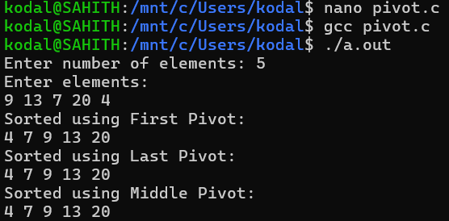

- Quick Select:

CODE:

#include <stdio.h>

// Swap function
void swap(int *a, int *b) {
int temp = *a;
*a = *b;
*b = temp;
}

// Partition function
int partition(int arr[], int low, int high) {
int pivot = arr[high];
int i = low;

for(int j = low; j < high; j++) {
if(arr[j] <= pivot) {
swap(&arr[i], &arr[j]);
i++;
}
}

swap(&arr[i], &arr[high]);
return i;
}

// Quick Select function
int quickSelect(int arr[], int low, int high, int k) {
if(low <= high) {
int pi = partition(arr, low, high);

if(pi == k)
return arr[pi];
else if(pi > k)
return quickSelect(arr, low, pi - 1, k);
else
return quickSelect(arr, pi + 1, high, k);
}
return -1;
}

int main() {
int arr[100], n, k;

printf("Enter number of elements: ");
scanf("%d", &n);

printf("Enter elements:\n");
for(int i = 0; i < n; i++)
scanf("%d", &arr[i]);

printf("Enter k (position): ");
scanf("%d", &k);

int result = quickSelect(arr, 0, n - 1, k - 1);

printf("%d-th smallest element is: %d\n", k, result);

return 0;
}

OUTPUT:

